Thermostat User Guide
Segundo – Bixby, Gilmore, Malcolm, & Ryerson Halls

The Segundo Res Halls are equipped with Pelican TS200H Thermostats. These thermostats provide increased energy efficiency by adjusting room temperatures accordingly based on pre-set temperature limits. Residents/guests can select a comfortable temperature up to 72 degrees in heating and as low as 70 degrees in cooling. Residents may also choose to turn off their unit and only run the fan. The system fan speed will take precedence over user selected speed if higher speeds are necessary to provide sufficient heating/cooling.
We manually change these buildings from heating to cooling depending on the time of the year. We typically send out a notification to all residents when the changeover will happen.

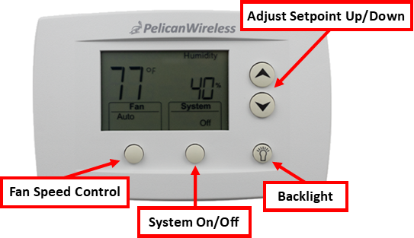
Troubleshooting:
- Are the windows open?
- If outside temperatures are colder than inside temperatures, close all windows to allow maximum efficiency.
- If outside temperatures are warmer than inside temperatures, open windows to allow increased heating.

If the above actions do not resolve the problem, please submit a service request on-line (Academic Year Residents and/or Staff). Contact your respective Area Service Desk if immediate response is required.



